**CMP4271: Online diary - Territorial acquisition**

***Introduction***

This week the group had to design a game which includes territorial acquisition, trading and alliances (team play).

The name of the game was Medieval Conquest. The team were asked to design a game which includes grabbing territory and team play, the team thought of the idea of a medieval type of game.

***Game Mechanics***

Figure 2.1

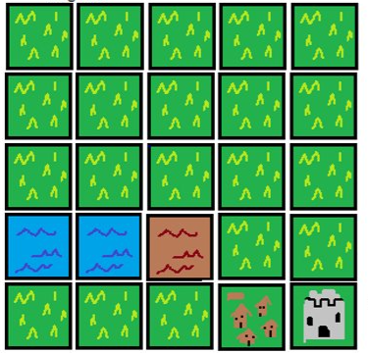The game mechanics for the game were relatively simple, it is a turn-based board game which included up to eight players. As the team had to implement an alliances feature, the players in the game were able to team up with other players, however the goal of the game was to be the last player standing. The board includes the map of England in the middle ages. As it was a medieval game, each player started with a castle and the goal was to conquer the other player’s castle in order to take their territory. Figure 2.1 on the right showed the map of the Medieval Conquest game, this was just a piece of it as the team was not able to create the whole map. This was from the player’s perspective and showed from where they would usually start.

***Materials***

The team mainly used Paint.Net to create the map of the game. Also, PowerPoint for the presentation.

***Rules***

* Everyone starts with a castle, a town and a goldmine and some grass​
* As it is a turn-based game it did included a six-number dice as well.
* The dice showed the players the amount of moves they had to make
* Turns are decided by a dice roll and players can do 2 things each turn to improve defense or offense​
* Players earn money(gold) per turn, and they earn more by having more villages.​
* Three players cannot be at the same place at the same time​
* Only up to 2 players on a square(they will be fighting).
* Loser goes back to their castle. Winner takes the village and stays there. ​
* Players win by claiming all the beginning castles or if everyone surrenders.

***Gameplay***

Each player had a piece in the start of the game which represented their avatar. Players had to go around the board to conquer small villages, these villages played a big role in the endgame as each village the player had generated gold which was a vital resource as it was the currency of the game. With gold, the players were able to build siege engines and recruit troops. The more villages a player had the richer they would have been. Players were able to purchase or sell villages to other players with money. As the players progressed through the game they started fighting. If two players were in the same spot a battle commenced, however if they were allies, they stayed together. If one player lost to another player over a territory, the player who lost returned to their original castle and lost all their troops, they stayed there until their turn comes up, to move again. The player who had won the battle would take over the territory and stay there. If a player reached a territory which had two enemies standing together in it, the player had to fight them both at the same time. In some point of the game players started to attack each other’s castles until the last player stands. If a player took over the castle of another player, the winner of the battle took over the villages and the territory from the loser.

***Teamwork***

The team consisted of three group members, and each was assigned a role when the game was designed, for example one member had to do the map of the game. Another had to do the gameplay and the mechanics and the third member had to do the rules and was responsible for asking questions to the other members in order to write the rules correctly.

***Reflection***

When the team looked back on their worked we found out that we couldn’t play test it as they developed an idea for the game but the board for the game was incomplete and the team agreed that they created too complicated mechanic, to implement and play test for the time that was given to them.